PLA Guide
Leadership

How to Use this Guide
This guide is meant to help you understand the knowledge and skills typically expected of someone who has a college-level understanding of Leadership.
This guide is also meant to help you go through the processes of thinking about your learning and writing your Prior Learning Request by answering the following questions, which will be explained more fully in the section, Writing your PLA Request:
- Describe what you do.
- Compare a real and hypothetical situation in this field.
- Identify informal “rules” in this field.
- Examine the role of a professional in this field.
- Apply your knowledge in a problem-solving situation.
- Identify critical issues in the field.
- Teach others.
- Offer additional information or evidence of your learning.

Learning Experiences
Leadership can be embodied in multiple positions. However, it must involve influencing others.

What is Leadership?
“Leadership is a process whereby an individual influences a group of individuals to achieve a common goal.” Northouse, Peter G. (2012). Leadership: Theory and Practice, 6th Edition. Sage Publications.

Leadership is a set of skills and behaviors which can be separate from title or assigned role in an organization. Leadership is specifically focused on motivating others to achieve goals based on an articulated vision. By contrast, Management is focused on the implementation of established business objectives.

The diagram below identifies many aspects of learning in this field. Your learning may fall within some areas and not others, based on your personal experience, and that’s o.k. You can consult other guides or use the general guide, if they are more appropriate to your learning.
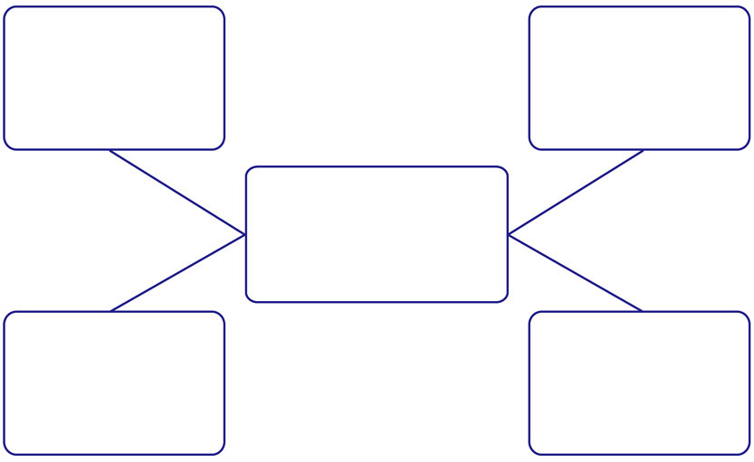
Motivates / encourages / empowers
Fosters collaboration and Teamwork
Searches for Opportunities to innovate and effect change

Sets an example / establishes principles
LEADERSHIP

Inspires / envisions the Future

Writing Your PLA Request
Please answer the questions below to the best of your ability.
- Please respond to the following:
- What were/are the positions that you have held which relate to this PLA?
- Briefly describe what did you do in those positions that relates to Leadership?
- What was the length of time you held each position?

- Considering the leadership behaviors and practices in the previous diagram:
  - Please provide examples of your leadership that you think fall under these broad leadership behaviors and practices
  - What leadership training, if any, did you receive?
  - What reading, self development or other experiences have helped develop your leadership knowledge or skills?

- Describe two scenarios in which you demonstrated leadership
  - Briefly describe your role in that scenario
  - How did you demonstrate leadership?
  - What was the result?
  - What did you learn from that scenario?
  - How did/could you apply that learning to another scenario (for example, at your workplace or a different setting)?

- Describe the skills and characteristics of an effective leader.

- Based on everything you have learned about leadership, what are some typical challenges leaders face and how do they overcome them?

- Identify several leaders with whom you are familiar. You have met these leaders in your personal or professional life or read about them.
  - What do you consider their strengths as leaders?
  - What do you consider their weaknesses as leaders?
  - What qualities or practices were you able to take away from their respective styles?
  - What leadership characteristics do they have in common?
  - How do they differ?

- Consider the following scenario: You’ve just become the leader of a new workgroup, what will you do to inspire and motivate your team to achieve the organization’s goals?

- Consider this scenario: You’ve been asked to mentor an employee who is being groomed for a leadership role. What leadership lessons have you learned that you consider critical to share with this individual?

- Offer any additional information or thoughts on this topic that you would like to discuss as part of your PLA evaluation.

Information to Help You Decide Credit Specifications for Your Request
College-level learning means that you can talk about what you know in some detail, come up with some general insights and “rules” about the topic, and apply those insights and rules to new situations.
- Introductory/Advanced: Leadership is often advanced. Students seeking advanced level credit should demonstrate breadth of scope and scale in all leadership practices.
- Liberal/Non-Liberal: Leadership is typically considered Liberal.
- General Education: Leadership typically does not fulfil any general education area.
Number of Credits
To determine the number of credits to request, think about your experience using this guide. If you answered most of the questions easily, and feel that you can confidently discuss areas related to this topic, you may want to request 3-4 credits, which is the equivalent of one college course. After your discussion, your evaluator will have the opportunity to recommend fewer or more credits based on his/her evaluation of your learning.
Level of Credits
To determine the level of your request think about your comfort level answering the questions. Did you feel confident answering the questions that asked you to interpret, analyze, compare, or generalize? Reflect on your learning in light of the information below to help you determine whether to request introductory or advanced-level credit. If you aren’t sure, discuss this with your mentor.
Introductory college-level learning (freshman/sophomore) means that you understand:
- Basic concepts, theories, and principles of a topic.
Advanced college-level learning (junior/senior level) means that you understand the topic more broadly and deeply. You may understand:
- What the broader field is about, based on your experience.
- Why something is done in a certain way.
- What you, yourself, think about the topic or field, as a result of blending others’ perspectives with your own understanding and judgment.
- How to analyze, synthesize, and evaluate information more abstractly, applying methods usually used in that field.
Examples of General PLA Topics and Level of Learning
 | PLA Topic – Building | PLA Topic – Project Management | PLA Topic – Spanish Culture
NOT college –level | Know how to put up wallboard | Work to complete items on a checklist given to you | Traveled in Spain twice, for two weeks each time
Intro. college-level | Understand why walls are constructed a certain way | Create a timeline and supervise the completion of tasks | Understand trends and practices related to daily life, holidays, food, religion, etc. Understand some Spanish history related to contemporary attitudes and practices
Advanced college level | Intro level plus:  Understand how to design a building so the walls stay up | Intro level plus:  Work to create cooperation of all parties concerned with the project; analyze problems or issues and amend the plan; evaluate the outcome of the project | Intro. level plus:  Understand nuances related to attitudes and practices. Know of and understand sub-groups within the overall culture. Understand more fully Spanish history related to contemporary attitudes and practices.

